|  |  |
| --- | --- |
| Project Development PhaseSprint Delivery - II | |
| Team ID | PNT2022TMID07016 |
| Project Name | Smart Farmer - IoT Enabled Smart Farming Monitoring Application |

# Building Project

# Connecting IoT simulator to IBM Watson IoT

# Give the credentials of your device in IBM Watson IoT Platform

# Click to connect

My credentials given to simulator are: Organization ID r3m467

Device Type NalaiyaThiran

Device ID NalaiyaThiran

Authentication Method use-token-auth

Authentication Token NalaiyaThiran

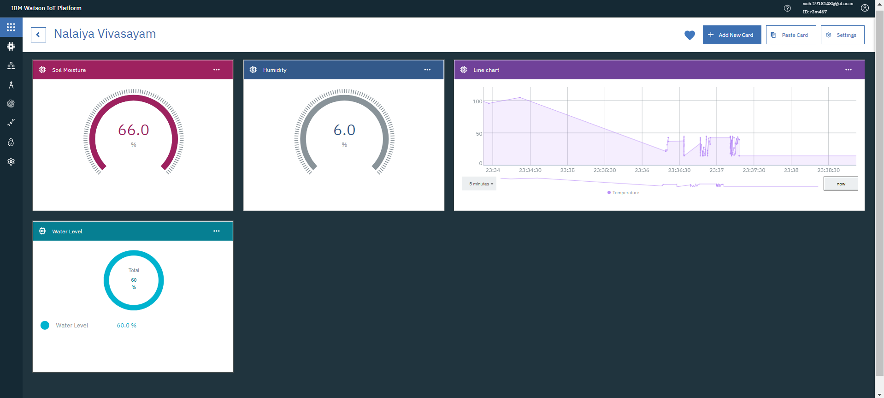

You can see the received data in graphs by creating cards in Boards tab

* You will receive the simulator data in cloud
* You can see the received data in Recent Events under your device
* Data received in this format (json)

{

"d": {

* "name": "xyz",
* "temperature": 27,
* "humidity": 26,
* "Moisture ": 31,
* “Water_Level”:60

}

}

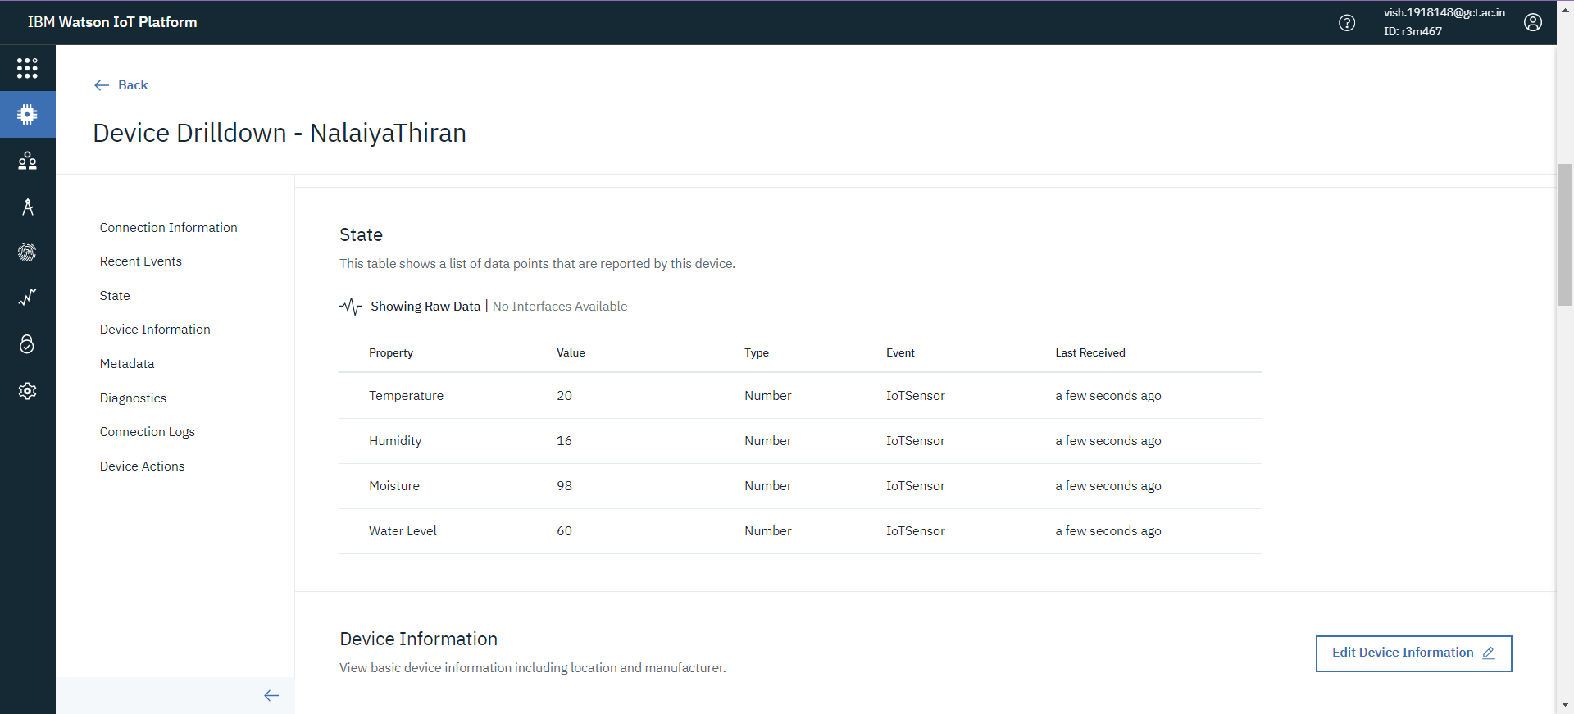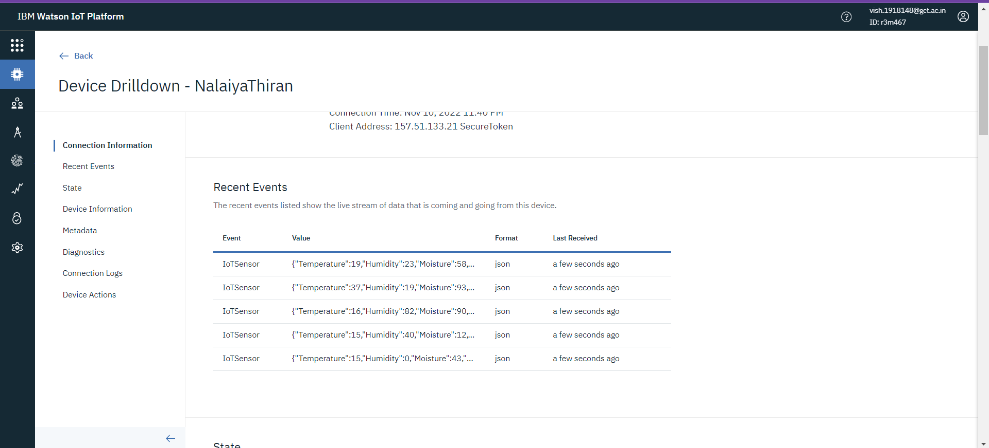

# Configuration of Node-Red to collect IBM cloud data

The node IBM IOT App In is added to Node-Red workflow. Then the appropriate device credentials obtained earlier are entered into the node to connect and fetch device telemetry to Node-Red.

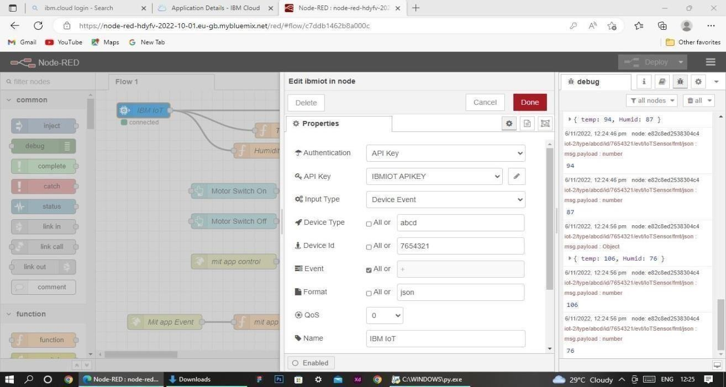

Once it is connected Node-Red receives data from the device Display the data using debug node for verification

Connect function node and write the Java script code to get each reading separately.

The Java script code for the function node is: msg.payload = msg.payloadd.temperature

return msg;

Finally connect Gauge nodes from dashboard to see the data in UI

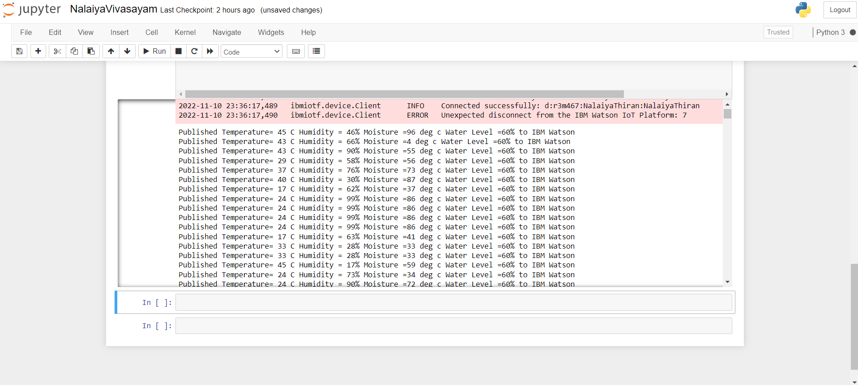

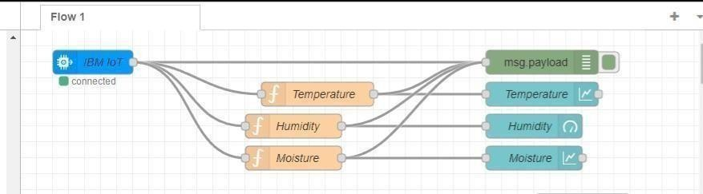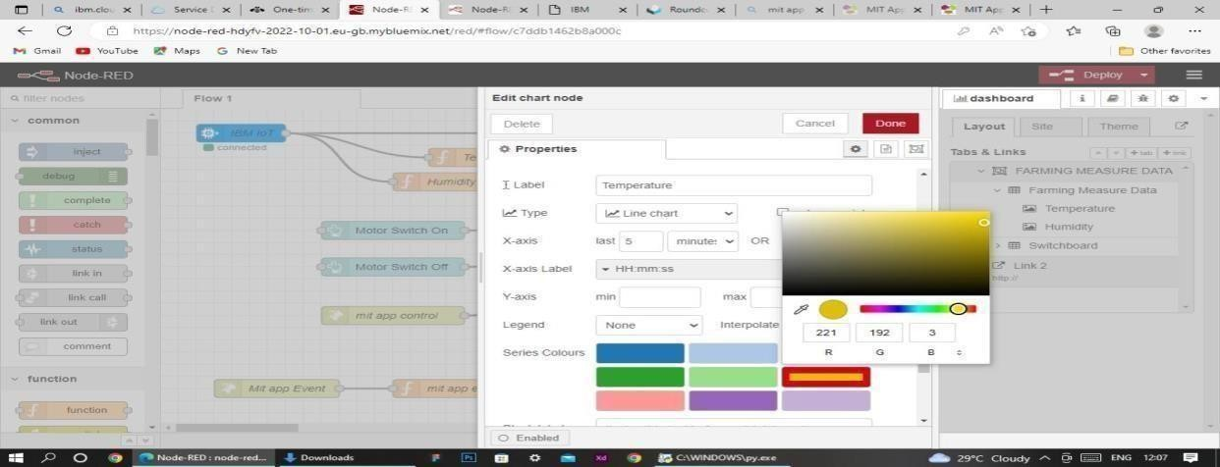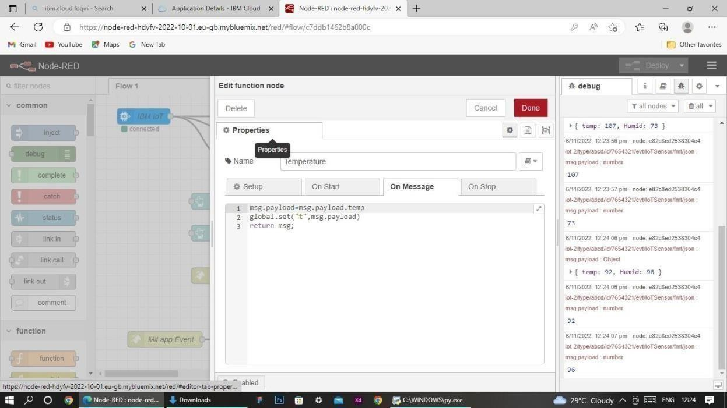Data received from the clou d in Node-Red console